# **Utilization of AI Tools in the Development of the Drone App**

The development of the Drone App involved the integration of various AI tools and technologies that significantly enhanced the efficiency and effectiveness of the coding process. Throughout the project, these tools were leveraged for code generation, debugging, and optimizing application performance.

## **Code Generation and Snippet Assistance**

One of the primary AI tools utilized during the development was an AI-powered code assistant. This tool assisted in generating boilerplate code and providing snippets for complex functionalities. For instance, when implementing user authentication with Firebase, the AI tool provided code snippets for handling authentication errors and token refreshment.

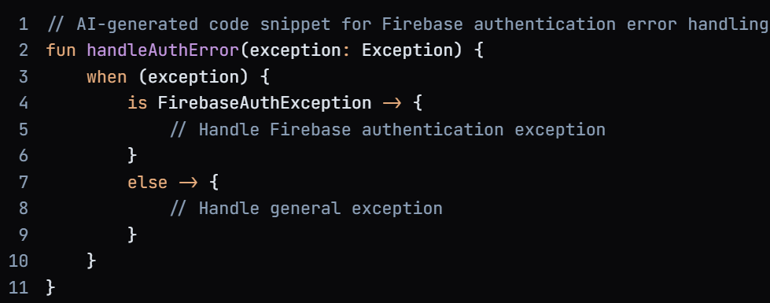

## **Debugging and Error Resolution**

Another AI tool employed during the development was an AI-driven debugging assistant. This tool helped identify and resolve errors in the codebase, significantly reducing debugging time. For example, when encountering a null pointer exception in the image gallery feature, the AI tool pinpointed the exact line of code causing the issue and provided a suggested solution.

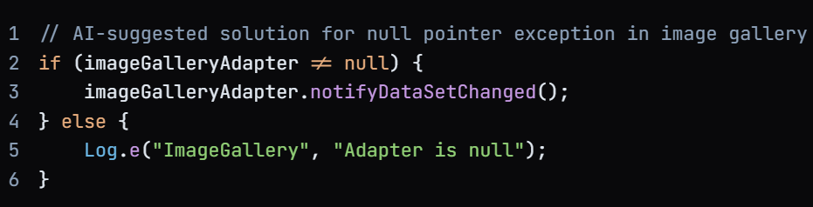

## **Conclusion**

The integration of AI tools and technologies played a vital role in the development of the Drone App. By leveraging these tools, the development process was accelerated, and the overall quality of the application was improved. The AI-powered code assistant, debugging tool, and image processing technologies enabled the development team to focus on high-level tasks, resulting in a more efficient and effective development process.